

YEAR: 10
SUBJECT: SCIENCE

Name: __________________________________________________

Date: __________________________ Form: __________________

TEST: Physics
TIME: 40 minutes
TOTAL MARKS: 35 marks

FORMULAE:
Speed: v = d / t
Acceleration: a = (v-u) / t
Momentum: p = m x v
Work: W = F x d

Question 1: (3 marks)
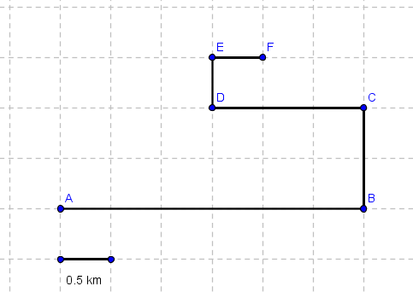

The above image is a dirt bike track. Using the scale, detail the distance from:
- B to A: ________________________________________________________
- D to B: ________________________________________________________
- F to A: ________________________________________________________

Question 2: (6 marks)

- If you travel 400 metres in 50 seconds, what is your speed? __________________________________________________________________________________________________________________________________________________________
- If you are travelling at 60 km/h, how long will it take you to travel 800 kilometres? __________________________________________________________________________________________________________________________________________________________

Question 3: (6 marks)

- Adam is test-driving his new car at 6 m/s. Adam applies force to the throttle, and within 4 seconds, he reaches 35 m/s. How much does Adams vehicle accelerate? ______________________________________________________________________________________________________________________________________________________
- Adams sister Jessica watches Adam zoom past her, and realises that she is also speeding. Jessica decides to slow down from 30 m/s to a comfortable 15 m/s, which takes her 2 seconds. How much has Jessica’s vehicle decelerated?
______________________________________________________________________________________________________________________________________________________

Question 4: (6 marks)

List each of Newton’s laws, and provide an example of where you would see this law in practice during your daily life:
Newton’s first law: ____________________________________________________________________________________________________________________________________________________________________
Newton’s second law: ____________________________________________________________________________________________________________________________________________________________________
Newton’s third law: ____________________________________________________________________________________________________________________________________________________________________

Question 5: (6 marks)

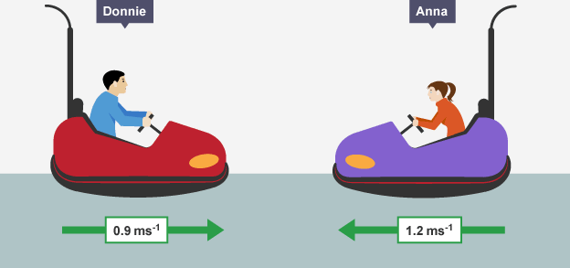

Donnie’s Mass: 700 kg Anna’s Mass: 660kg

- What is Donnie’s momentum? __________________________________________________________________________________________________________________________________________________________

- What is Anna’s momentum? __________________________________________________________________________________________________________________________________________________________

- Once Donnie and Anna collide, detail the final momentum and the direction. __________________________________________________________________________________________________________________________________________________________

Question 6: (4 marks)


Above is a picture of Robert. On Friday, Robert’s boss asked him to complete a report due by Monday. Not only did Robert not do the report, he also came to work 10 minutes late on Monday. Robert lost his job, and was asked to pack up immediately.
Robert had two options; either pack all his items into one large box, or to pack his items into three smaller boxes. The distance from his office to his car was 600 metres. The large box had a force of 80 N, whilst the smaller boxes had a force of 25 N.

a) How much work would Robert perform carrying the first box? ____________________________________________________________________________________________________________________________________________________________________

b) How much work would Robert perform carrying the three smaller boxes? ____________________________________________________________________________________________________________________________________________________________________

Question 7: (4 marks)

a) State the law of conservation of energy: ____________________________________________________________________________________________________________________________________________________________________
b) List two forms of “waste energy”
____________________________________________________________________________________________________________________________________________________________________

END OF TEST – PLEASE CHECK YOUR WORK

